Employee Module

Hours_Worked_pay= Hours_Worked * 30

Basic_Salary = Allowance + Hours_Worked_Pay

Total_Salary = Basic_Salary – Monthly_Deductions

Enter Emp_ID

Basic_Salary = 0

Allowance = 0

Monthly_Deduction = 0

Total_Salary = 0

Hours_Worked_Pay = 0

Begin

Employee Salary Calculation

If Emp_Status = “Permanent” and Job Grade <= 5

Hours_Worked_pay= Hours_Worked * 20

Basic_Salary = Allowance + Hours_Worked_Pay

Total_Salary = Basic_Salary – Monthly_Deductions

Hours_Worked_Pay = Hours_Worked * 30.00

Basic_Salary = Monthly_Allowance + Hours_Worked_Pay

Total_Salary = Basic_Salary - Monthly_Deductions

If Emp_Status = "Contract" and Job_Grade <= 5 than

Hours_Worked_Pay = Hours_Worked * 20.00

Basic_Salary = Monthly_Allowance + Hours_Worked_Pay

Total_Salary = Basic_Salary - Monthly_Deductions

Pseudocode

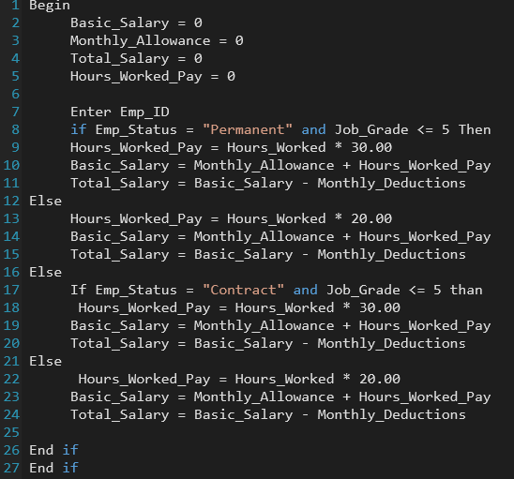

Employee Module